Alexandria Alternative Energy Meetup

There is more than one way to use geothermal heating and cooling!
Thursday, October 13, 2016
6:00 PM
Energy House Solutions Center
Location
4603A Eisenhower Ave, Alexandria, VA (edit map)
4603A Eisenhower Ave Alexandria VA 22304 - Come to end of exit off 495 onto Eisenhower Ave and our Center is across the street. Look for our sign Energy House Solutions Center
Meetup
Meet experts in the field of residential Geothermal here is the DC area. Rich Abernathy of Air Cool and Heat, (a true Geothermal Whisperer) will be our keynote speaker. Rich and other experts that are being assembled, will be on hand to explain many the uses of Geothermal in today's homes. Did you know?
Up to 90% of your hot water can be provided for free with Geothermal.
Geothermal is one of the best sources for radiant floor heating.
Residential Geothermal can be used in new or existing homes.
Find out the most innovative geothermal equipment in the industry today.
Join This Meetup – We are looking for additional members
https://www.meetup.com/Alexandria-Alternative-Energy-Meetup/events/234427846/
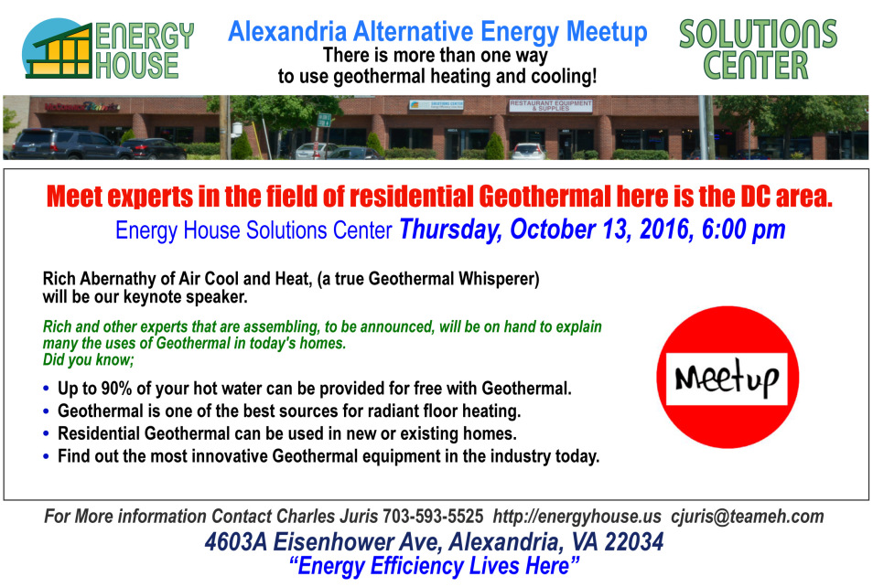

EHLG – Energy House Links Group
Special Guest Speaker - Welcome BEM Controls
http://www.bemcontrols.com/

Thursday, October 6, 2016
Noon to 2 pm
Energy House Solutions Center
Location
4603A Eisenhower Ave, Alexandria, VA (edit map)
4603A Eisenhower Ave Alexandria VA 22304 - Come to end of exit off 495 onto Eisenhower Ave and our Center is across the street. Look for our sign Energy House Solutions Center

EHLG Monthly Meeting – Join this local nonprofit group of energy efficient companies here in the Washington DC area dedicated to advancing the educational process of energy efficiency.

Monthly Lunch Meeting for our members and their guests

This month’s Keynote Speaker – BEM Controls of Falls Church - BEMOSS™-plus is the core of a very powerful, but low-cost building automation system that uses an agent-based technology to optimize building operations by controlling major electricity consuming devices (HVAC and lighting loads) and internal energy sources (PV and storage) in buildings.

Join the EHLG – Membership to this organization is open to the general business community. Meetings are held the first Thursday of each month. Speakers on energy efficiency are scheduled to advance our members on different aspects of this constantly changing industry. For more information please contact this chapters President, Salvatore Benvenga salvatore@sbdesignstudios.com
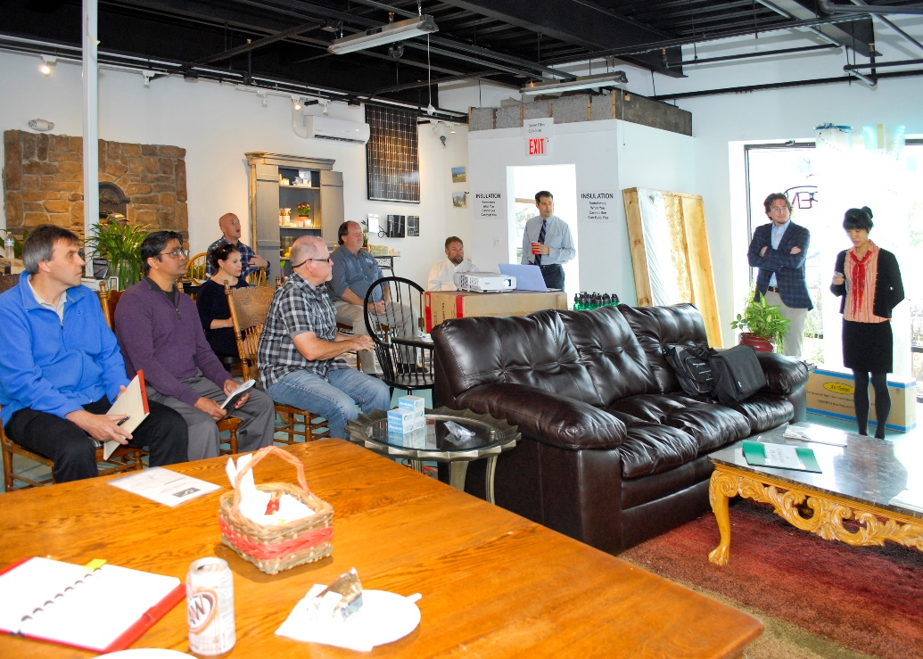

Another very successful EHLG meeting. One of the most cutting edge innovations in energy efficiency, new to the market and presented to the members of the EHLG. Great success!

Green Fiber Insulation Day
At the
Energy House Solutions Center
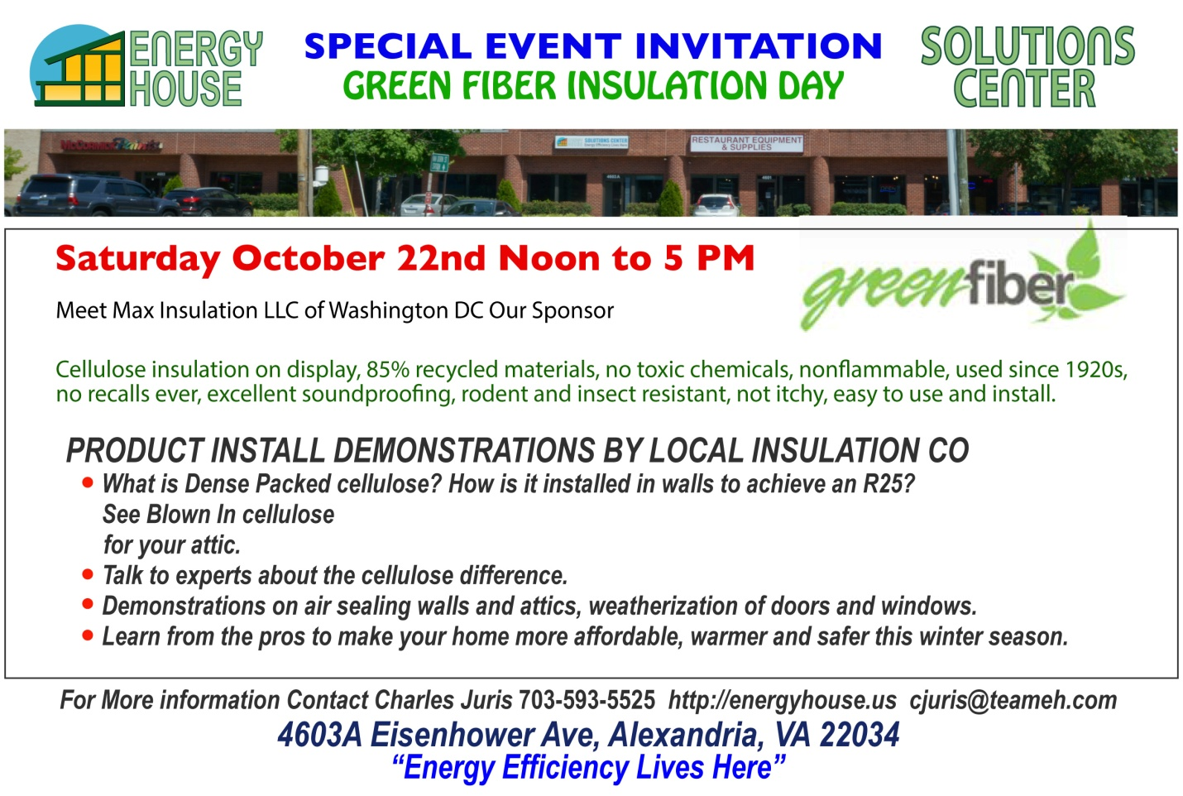

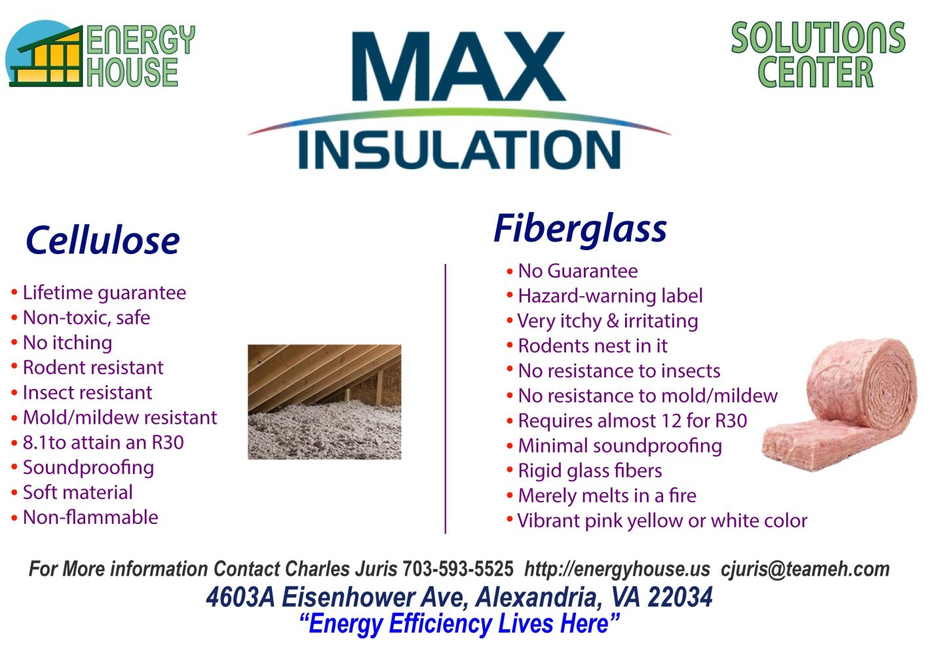

INNOVATION SESSIONS INVITATION
POSTPONED
GREEN REALTORS WORKSHOP
Thursday October 20, 2016 6pm to 8pm

Homeowners have an Edge with Energy Efficient Homes!
From the desk of Wendy Benvenga | Realtor, GREEN

Welcome to the first monthly educational piece focused on providing you with up to date information on Energy Efficient Homes, Sustainability and Smart Home Technology.

Meet Energy Efficiency Experts in the Field at the Solutions Center Showroom;

- Insulation & Weatherization
- SMART Tech
- Windows & Doors
- Sustainable Cleaning Products/Soaps/Scrubs
- Heating and Cooling Systems
- MORE

Wendy Benvenga is a local Green relator who also serves as the Educational Outreach Chairwoman for the Energy House Links Group.
Quarterly Educational Workshops begin Thursday, October 20, 2016 at the Energy House Solutions Center in Alexandria, VA! Directions:
Direct Line: 571-989-3088 Email: WendyBenvenga@gmail.com

POSTPONED
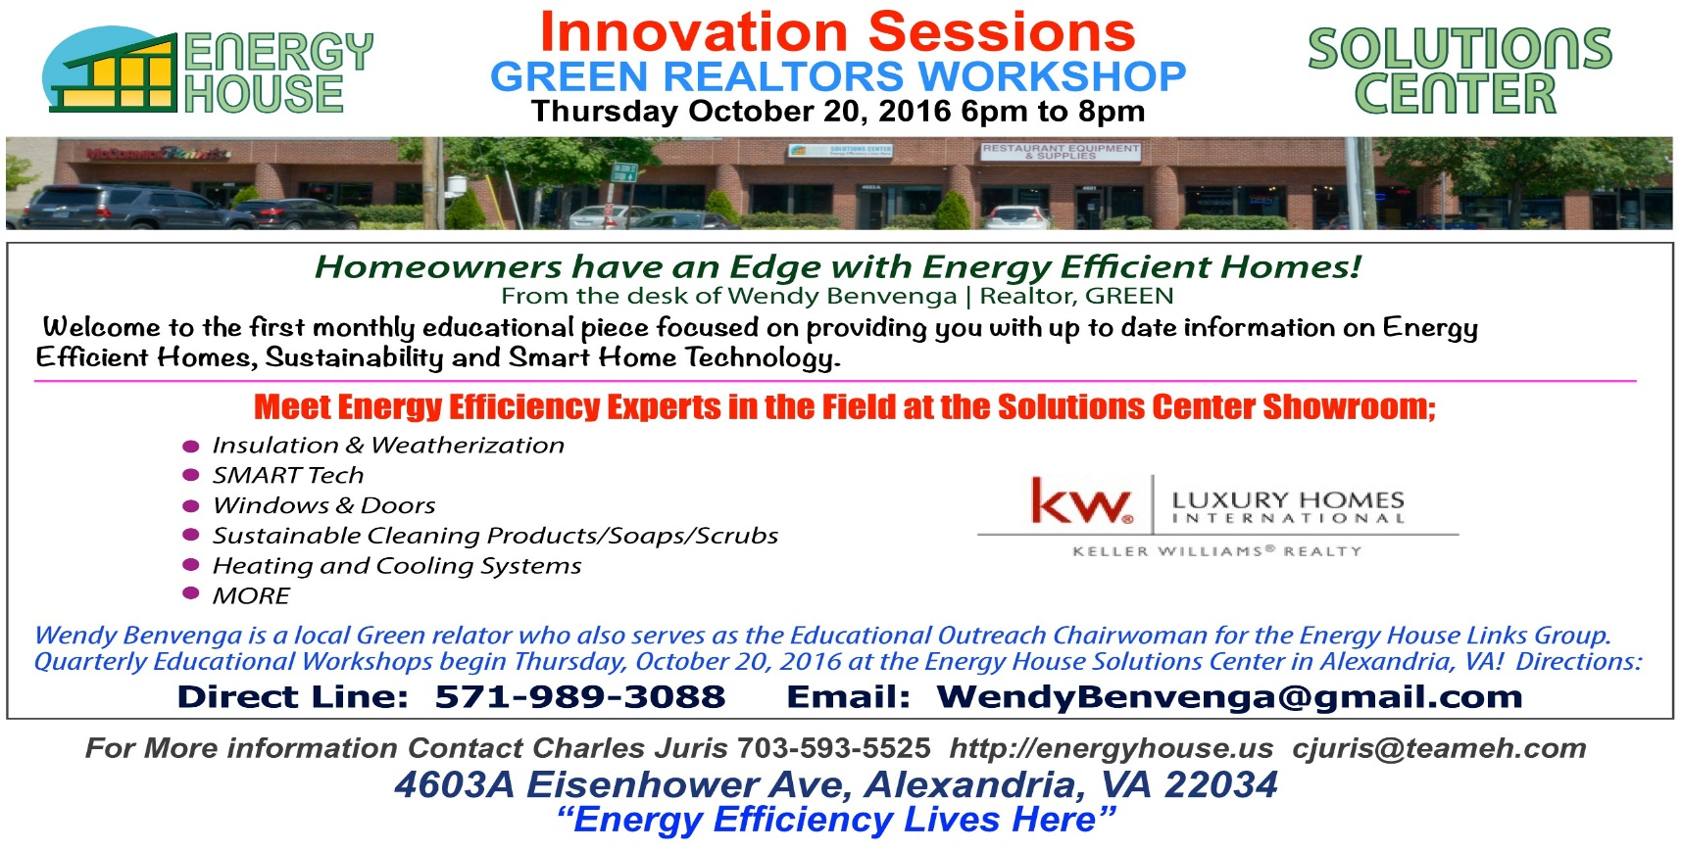

INNOVATION SESSIONS INVITATION
MEET 3 LOCAL GREEN ARCHITECTS
Thursday October 27, 2016 6pm to 8pm

Homeowners here is your chance to meet 3 local green architects, with no obligation, at the Energy House Solutions Center at 4603A Eisenhower Ave in Alexandria VA 22301 to discuss your upcoming project. 3 Green Local Architects have agreed to attend this event to discuss the process of making your dream, not only come true but also how to make it energy efficient.
Event Overview
- What makes a job Green and Energy Efficient?
- What is the process of starting your new project?
- Changes in the building code that will affect your project that you need to know about.
- How do you set a preliminary budget for your proposed job?
- How to find a Green General Contractor for your project.
- MORE
SPECIAL OFFER – Come to this event, meet with these Green Architects during this event, pick one to visit your site and you will receive a 1 hour FREE consultation of your project from that architect.

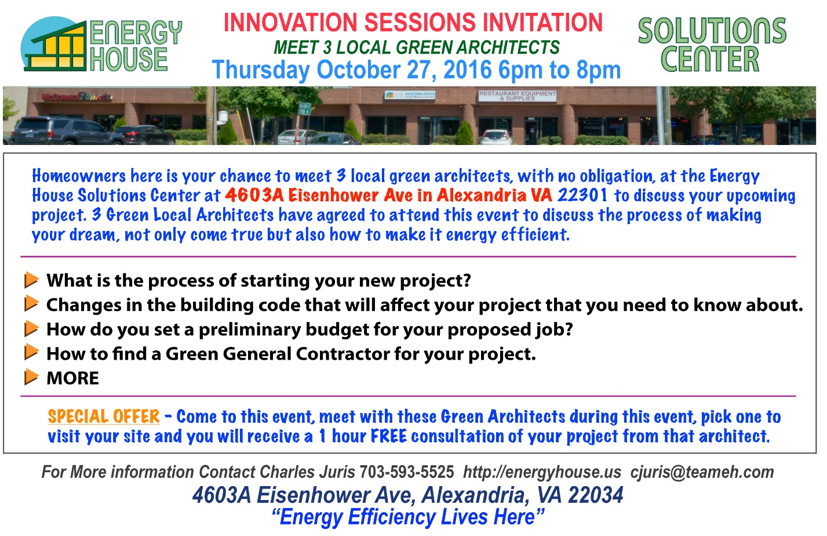

INNOVATION SESSIONS INVITATION
HEAR HILLARY CLINTONS POSITION ON ENERGY EFFICIENCY
Tuesday October 18, 2016 6pm to 8pm
Here is your chance to hear firsthand from Hillary Clinton surrogate Trevor Dean, campaign volunteer, Hillary former staff member, in attendance at the Energy House Solutions Center at 4603A Eisenhower Ave in Alexandria VA 22301 to present the positions of the Democratic Nominee for President of the United State on Energy Efficiency and Clean Jobs for the future. The Energy House has invited both national candidates and their representatives to come to the Solutions Center to present their views on this subject to our customers and local residents.

- Defend, implement, and extend smart pollution and efficiency standards
- Launch a $60 billion Clean Energy Challenge
- Invest in clean energy infrastructure, innovation, manufacturing and workforce development
- Ensure safe and responsible energy production.
- Cut the billions of wasteful tax subsidies oil and gas companies
- Promote conservation and collaborative stewardship
I won’t let anyone take us backward, deny our economy the benefits of harnessing a clean energy future, or force our children to endure the catastrophe that would result from unchecked climate change.
Hillary, November 29, 2015 https://www.facebook.com/hillaryclinton/videos/1129091543814040/
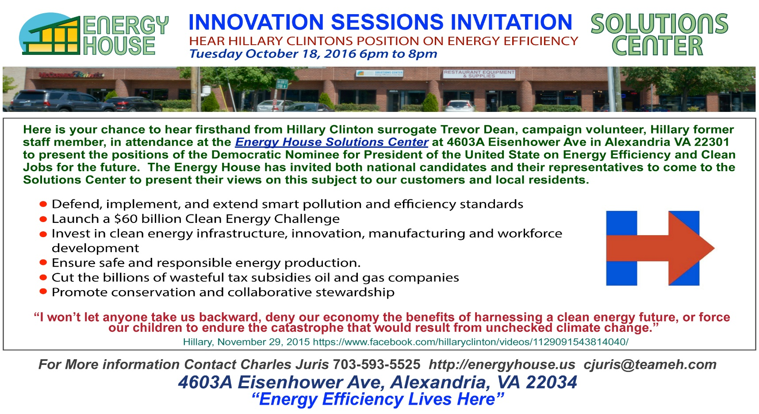
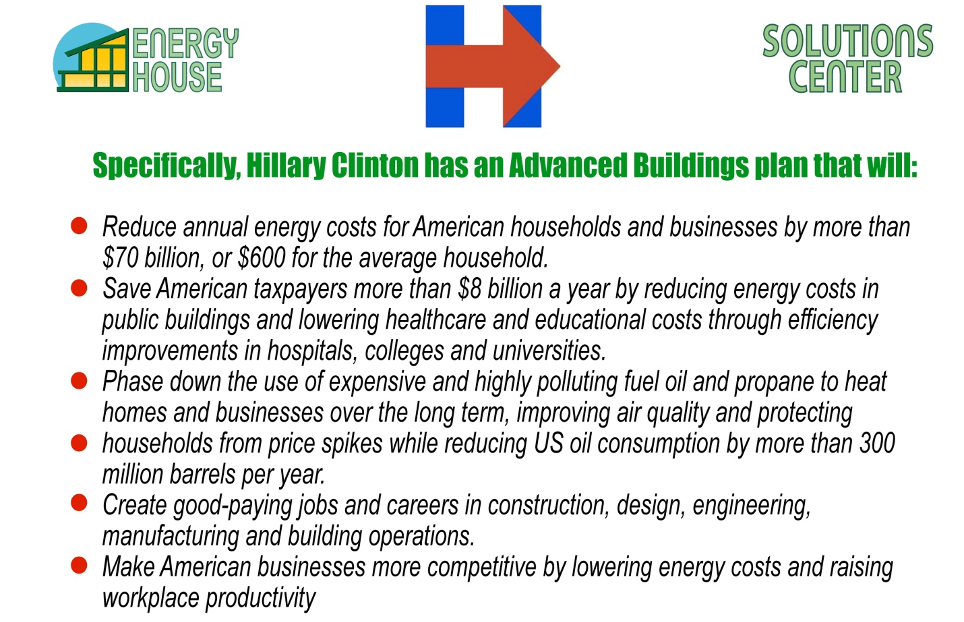

REVIEW OF EVENT

Ok if you missed this event you missed a great Innovation Session at the Energy House Solution Center. First, catering by Aldo’s Italian kitchen of hot meatball, eggplant and chicken parmesan sandwiches were a very big hit. Thanks Emmanuel for another great job at our Solutions Center Innovation Sessions.

We thought it was a great information opportunity on the current election situation and energy efficiency for the future. Our two keynote speakers, Trevor Dean and Senator Adam Ebbin, did a great job and they lead us all is a lively discussion of our energy situation here in VA and across the country. Given the information that they provided it is clear all our votes are going to be important this November.

What we have gotten out of all of our sessions, over the past two months, is that the passion for energy efficiency is growing and we have been privileged to meet so many wonderful people, some as customers, some as colleagues and others as new friends.

Thanks again for attending and we look forward to you sharing your thoughts on last night’s event with other energy enthusiast that could not make this event. “The best is yet to come!”

